

**CHAPTER 1**

**INTRODUCTION**



**TO**



**SYSTEM**



**INTRODUCTION TO SYSTEM**



Poultry farming is one of the most dynamic and rapidly growing sectors in the global agricultural industry, driven by the increasing demand for poultry products such as meat and eggs. As the world population continues to grow, so does the need for efficient, sustainable, and high-quality food production. In this context, environmental control in poultry farming has emerged as a critical factor in ensuring the health, welfare, and productivity of birds. Environmental control refers to the management and regulation of various factors within poultry houses, including temperature, humidity, ventilation, lighting, and air quality, to create optimal living conditions for birds. By maintaining these factors within specific ranges, farmers can minimize stress, prevent diseases, and maximize growth rates and egg production, ultimately leading to higher profitability and sustainability.

The importance of environmental control in poultry farming cannot be overstated. Poultry birds, particularly chickens, are highly sensitive to their surroundings. Unlike humans, they lack sweat glands and rely on external conditions to regulate their body temperature. This makes them particularly vulnerable to environmental stressors such as extreme temperatures, poor air quality, and improper lighting. For instance, heat stress can lead to reduced feed intake, lower growth rates, and increased mortality, while cold stress can suppress immune function and increase susceptibility to diseases. Similarly, poor ventilation can result in the buildup of harmful gases like ammonia and carbon dioxide, which can cause respiratory issues and other health problems. On the other hand, optimal environmental conditions can enhance bird performance, improve feed conversion ratios, and reduce mortality rates, leading to better economic outcomes for farmers.

The concept of environmental control in poultry farming has evolved significantly over the years. Traditional poultry farming methods relied heavily on natural conditions, with farmers having limited control over environmental factors. However, with the advent of modern technologies and intensive farming practices, the industry has shifted towards more controlled and automated systems. Today, advanced environmental control systems use sensors, computers, and automated equipment to monitor and regulate temperature, humidity, ventilation, and lighting in real-time. These systems not only improve the precision and efficiency of environmental management but also reduce labor costs and minimize human error. For example, computerized ventilation systems can adjust airflow based on the numberof birds, outside weather conditions, and internal air quality, ensuring that birds are always in a comfortable and healthy environment.

One of the key components of environmental control in poultry farming is temperature regulation. Poultry birds have a narrow range of thermal comfort, and even slight deviations from this range can have significant impacts on their health and productivity. For broilers, the optimal temperature range is typically between 21°C and 27°C, while for layers, it is slightly lower, between 18°C and 24°C. Young chicks, on the other hand, require higher temperatures, around 32°C to 35°C, during their first week of life, which are gradually reduced as they grow. To maintain these temperatures, farmers use a combination of heaters, fans, and cooling systems. In colder climates, heaters and insulated housing are used to prevent cold stress, while in hotter climates, evaporative cooling systems and fans are employed to combat heat stress. Proper temperature control not only ensures bird comfort but also improves feed efficiency and growth rates, leading to better economic outcomes.

Humidity control is another critical aspect of environmental management in poultry farming. High humidity levels can lead to wet litter, which promotes the growth of pathogens and increases the risk of diseases such as footpad dermatitis and respiratory infections. On the other hand, low humidity can cause dehydration and reduce bird performance. The optimal humidity range for poultry houses is generally between 50% and 70%. To maintain this range, farmers use ventilation systems to remove excess moisture and dehumidifiers to reduce humidity levels when necessary. Proper humidity control not only improves bird health but also enhances litter quality, making it easier to manage and dispose .



**EXISTING SYSTEM**



**EXISTING SYSTEM :**

An existing poultry farm management system is a comprehensive tool designed to improve farm operations by managing and automating various tasks such as inventory control, feed management, health monitoring, egg production, and financial accounting. The system allows farm managers to track the growth and performance of poultry, monitor environmental conditions like temperature and humidity, and ensure proper care and nutrition. It also offers features like automated reporting, real-time alerts for health concerns, and performance analytics to enhance decision-making.

Additionally, these systems often integrate with automated devices such as feeders, temperature sensors, and water dispensers to optimize operations. They also help reduce human errors, improve record-keeping, and ensure compliance with industry regulations. While existing systems significantly improve efficiency and productivity, they may have limitations such as scalability, ease of use, and real-time data processing. Despite these challenges, the systems offer valuable insights and support better management of poultry farm operations.

**Problems in Existing System:**

1.Scalability Issues: Many systems are not easily scalable, limiting their ability to handle increased farm size or expansion without significant upgrades or modifications.

2.User-Friendliness: Some systems can be complex or not intuitive, making them difficult for farm workers or managers to use efficiently without extensive training.

3.Data Integration: Integration with other farming technologies, such as IoT devices, may be limited or challenging, leading to fragmented data and inefficiencies in automation.

4.Real-Time Data Processing: Some systems lack the ability to process data in real-time, leading to delays in critical decision-making, especially when managing poultry health.

5.High Costs: Advanced systems can be expensive, making them inaccessible for smaller farms with limited budgets.



**NEED AND SCOPE OF COMPUTER SYSTEM**



**Need Of Poultry Farm:**

1. **Skill Development & Training:** The Placement Cell can provide training resources and certifications to improve employability.

It can help in matching skills with job requirements for better job placements.

1. **Efficient Recruitment:** The app can act as a hiring hub where farms post job vacancies.

Poultry professionals can apply directly through the app.

1. **Bridging the Employment Gap**: Many poultry farms need qualified managers and workers but struggle to find the right talent.

Job seekers, including farm managers, veterinarians, and laborers.

1. **Internship & Apprenticeship Opportunities:** Newcomers can find internships to gain hands-on experience.

Farms can find trainees who can later become full-time employees.

1. **Digital Job Marketplace for Poultry Industry:** Creates a centralized job portal where poultry farms can list openings for managers, veterinarians, farmhands, and technicians. Employers can **filter candidates** based on qualifications, experience.

**Scope of Poultry Farm:**

1. **Job Opportunities in Poultry Farming**– Poultry Farm Managers overseeing daily farm operations and productivity.
2. **AI-Based Job Matching and Recruitment System**– Real-time notifications for job openings and application status updates.
3. **Training and Skill Development Programs**– Online courses and certifications in poultry farm management, animal health, and sustainability.
4. **Internship and Apprenticeship Opportunities**– Structured internship programs for students and fresh graduates in poultry management.



**ORGANIZATIONAL PROFILE**



**Poultry Farm Management System**

**Address:**

At-Post : Targaon Station , Tel : Koregaon,

Dist : Satara , 415107

**Contact No:**

7083436699

**Email**

**Id:**

Ajitmore4422@gmail.com



**CHAPTER 2**

**PROPOSED SYSTEM**



**PROPOSED SYSTEM**



The Poultry farming is a significant sector in the agricultural industry, providing a major source of protein through meat and eggs. However, managing a poultry farm requires continuous monitoring of various factors such as bird health, feed management, environmental conditions, production tracking, and workforce coordination. Traditional methods of poultry farm management often lead to inefficiencies, increased mortality rates, and financial losses due to lack of real-time monitoring and automation.

To address these challenges, the **Poultry Farm Management System Application** is designed as a **comprehensive digital solution** to help farm owners and managers efficiently handle all aspects of poultry farm operations. The application integrates **automation, data analytics, and artificial intelligence** to optimize farm productivity, reduce losses, and improve profitability.

1. **Farm Management Dashboard:**

Displays real-time data on flock size, health, feed consumption, and production rate

Provides daily task management for workers and managers.

Generates automated reports for decision-making.

1. **Poultry Health & Disease Management:**

Tracks bird mortality, weight gain, and disease symptoms.

Includes an AI-powered disease detection system based on symptoms.

Provides vaccination schedules and automated reminders.

Allows online consultation with veterinarians.

1. **Feed & Nutrition Management:**

Tracks daily feed consumption and calculates Feed Conversion Ratio (FCR)

Provides AI-based diet recommendations for optimized bird growth

Manages feed stock levels and automated reordering alerts.

# 



**OBJECTIVES OF SYSTEM**



The **Poultry Farm Managememt Application** is designed to streamline farm operations, enhance productivity, and improve profitability through automation and real-time monitoring. The key objectives of the system are:

**1. Efficient Farm Management**

* Provide a centralized platform to monitor and manage poultry farm activities.
* Automate daily farm operations, including feeding, health tracking, and production management.

**2. Health and Disease Management**

* Track poultry health, mortality rates, and symptoms in real time.
* Provide automated vaccination schedules and reminders.
* **3. Environmental Control and Optimization**
* Monitor and regulate temperature, humidity, and air quality using IoT sensors.
* Provide automated alerts for extreme environmental conditions affecting poultry health.
* Improve flock welfare by optimizing ventilation and biosecurity measures.

**4. Feed and Nutrition Management**

* Optimize feed consumption with AI-driven recommendations.
* Track feed stock levels and automate reordering to prevent shortages.
* Improve feed conversion ratio (FCR) to maximize efficiency and reduce costs.

**5. Workforce and Placement Cell Management**

* Provide a job portal for hiring skilled farm managers, veterinarians, and workers.
* Offer AI-based resume matching and candidate selection for farm owners.
* Facilitate training programs to upskill workers and improve efficiency.

**7. Sales and Market Integration**

* Enable direct selling of eggs, meat, and live birds through an online marketplace.
* Provide dynamic pricing recommendations based on market trends.



# SOFTWARE REQUIREMENT SPECIFICATION



**Requirement Gathering: -**

The **functional requirements** of the system include a comprehensive farm management dashboard that displays real-time data on flock size, health, feed consumption, and production rates. It should allow farm managers to automate daily tasks, track poultry health, and manage vaccination schedules. The system must integrate IoT-based sensors for environmental control, enabling farm owners to monitor temperature, humidity, and air quality. It should also have AI-powered features for feed optimization, disease detection, and production forecasting. The Placement Cell module is a critical feature that will allow farm owners to post job openings, and candidates to upload resumes. The system should also offer training programs, internships, and skills development for farm workers.

**User Requirements: -**

**Student Requirements:**

1. Internship and Apprenticeship Opportunities.
2. Job Portal and Career Guidance.
3. Real-Time Farm Data Access for Learning

**Recruiter Requirements:**

1. Job Posting and Management.
2. Resume and Candidate Database.
3. AI-Based Candidate Matching.

**Administrator Requirements:**

1. Coordination with Farm Owners and Managers.
2. Compliance and Documentation Management.
3. User Management, Job Posting Approval and Management.



**ANALYSIS**

**SYSTEM**

**CHAPTER 3**



# SYSTEM ANALYSIS



System analysis is a critical phase in the development of the Poultry Farm Management Application. It involves studying and understanding the requirements, processes, and workflows within the poultry farming environment to ensure the design and functionality of the system align with the needs of its users, including farm owners, managers, workers, recruiters, and students. The analysis phase serves as a blueprint for the subsequent stages of development, providing a clear roadmap for creating a functional and user-friendly application.

## 1. Problem Definition:

## Manual and inefficient farm management: Current systems often rely on paper-based records or manual tracking, leading to inefficiencies and human errors.

## Limited access to real-time data: Farm owners and managers often lack access to real-time environmental data, health metrics, and production rates, making decision-making difficult.

## Inadequate health and disease management: Many poultry farms struggle with monitoring and managing the health of their flocks, leading to losses due to diseases or poor nutrition

**2**.**Stakeholders and Users:**

## Farm Owners and Managers: They require features to manage daily farm operations, monitor poultry health, control the environment, optimize feeding, and track production.

## Farm Workers: They need a user-friendly interface to access their daily tasks, track progress, report issues, and receive real-time updates on farm activities.

## Veterinarians: They need tools for monitoring poultry health, recording treatments, managing vaccination schedules, and diagnosing diseases.

## 3.Farm Management:

## Dashboard for displaying real-time farm data (temperature, humidity, health, production rates).

## Automated scheduling of daily tasks (feeding, vaccination, cleaning).

## Monitoring of poultry health, including tracking diseases and treatments.

## Environmental control features (IoT integration for temperature, humidity, and air quality).

## 4. Functional Requirements

Student Registration: Students should be able to create profiles, upload resumes, and apply for jobs.

Company Registration: Companies can create profiles, post job openings, and shortlist candidates.

Job Search: Students should be able to search for jobs based on various filters like job role, company, location, etc.

Interview Scheduling: The system must allow companies and students to schedule interviews.

Feedback Management: Post-interview feedback should be captured for continuous improvement.

Placement Status: Students should be able to track the status of their applications.

Reports and Analytics: Admin and placement officers need access to reports for performance tracking, placement statistics, etc.

## 5. Non-Functional Requirements

Scalability: The system must be scalable to accommodate both small and large poultry farms. As the farm grows, the system should be able to handle increased data and users without compromising performance.

Usability: The interface should be intuitive and easy to use, especially for farmers with limited technical knowledge. It should include multilingual support for diverse users.

Security: Data security is a priority. Sensitive information such as health records, employee details, and financial data should be encrypted and stored securely. Role-based access controls should be implemented to ensure appropriate data access.

Reliability: The application must be reliable, ensuring uptime and consistent performance even in remote areas with limited internet connectivity. The system should support offline functionality and sync data when the internet is available.

Performance: The system should perform efficiently, with quick response times for real-time data processing, especially in the case of farm health monitoring and environmental controls.



# SYSTEM DIAGRAM



# Data Flow Diagram (DFD)

* **Zero-Level DFD:**

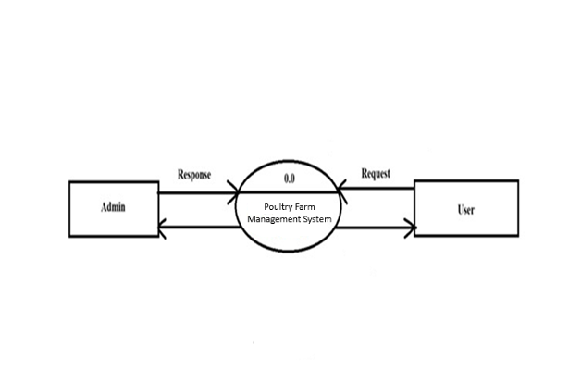

* **First Level Diagram For Admin:**

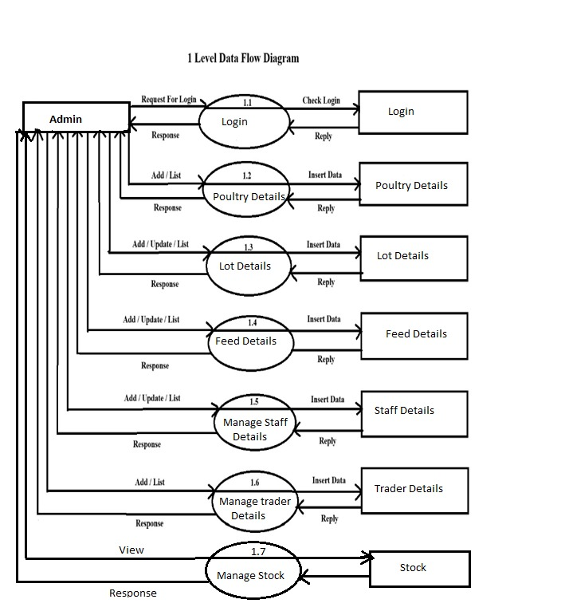

# Entity Relationship Diagr(ERD)

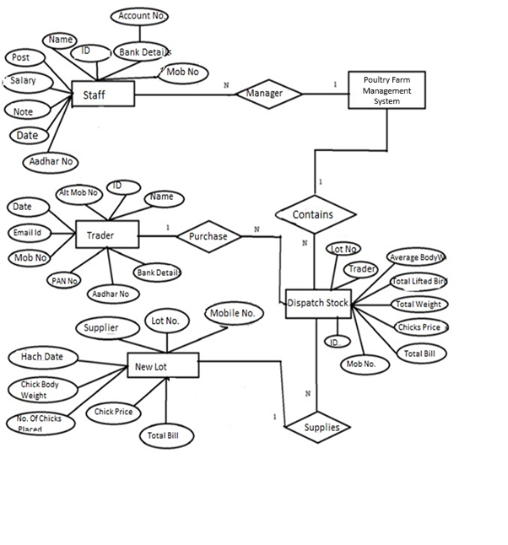



**DESIGN**

**SYSTEM**

**CHAPTER 4**



# DATABASE DESIGN



## Table Name:- Login

**Description**:-It Store Login Information

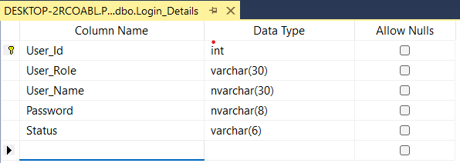

**Table Name:-** Lot Details

**Description:-** It Store Lot Daily Information

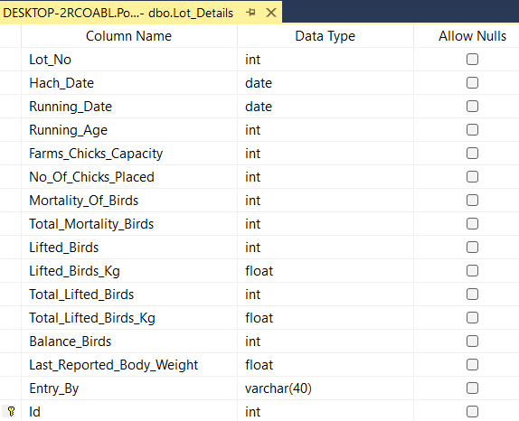

**Table Name:-**Feed Purchase Details

**Description:-**It Stores Purchase Details

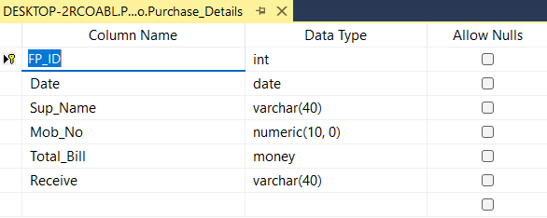

**Table Name**:-Feed Purchase Entry

**Description**:-This Table Stores Information Of Feed Purchase.

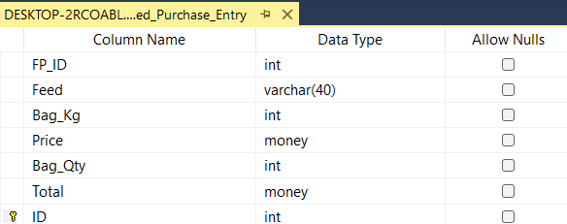

**Table Name:-** Dispatch Details

**Description**:- This Is Used To Dispatch Stock.

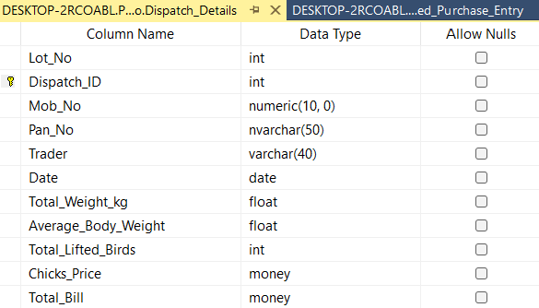

## Table Name:- Expence Details

**Description:-** It store Expence Details Of Poultry .

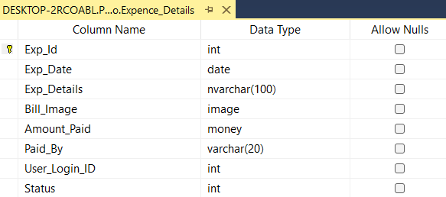

# 



# INPUT/OUTPUT DESIGN



## Login Form:

## 

* 1. Admin Login Screen:

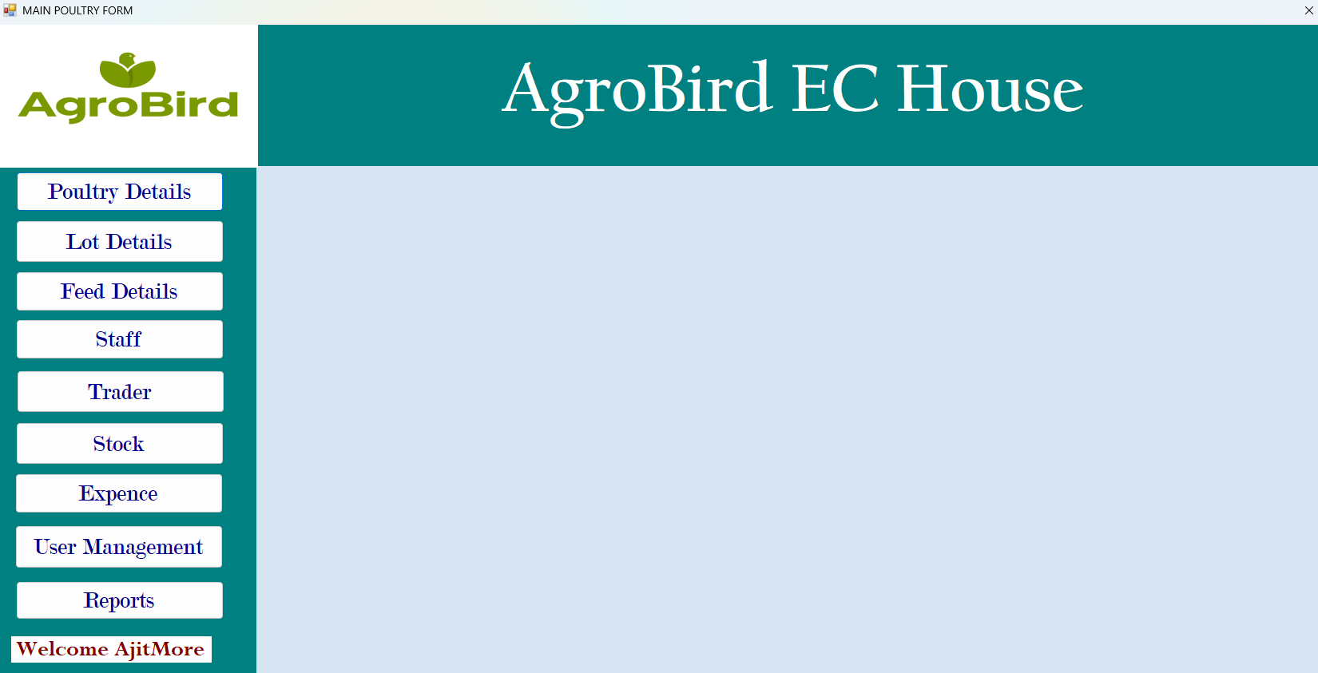

## Lot Entry Status:

## 

* 1. New Lot Entry**:**

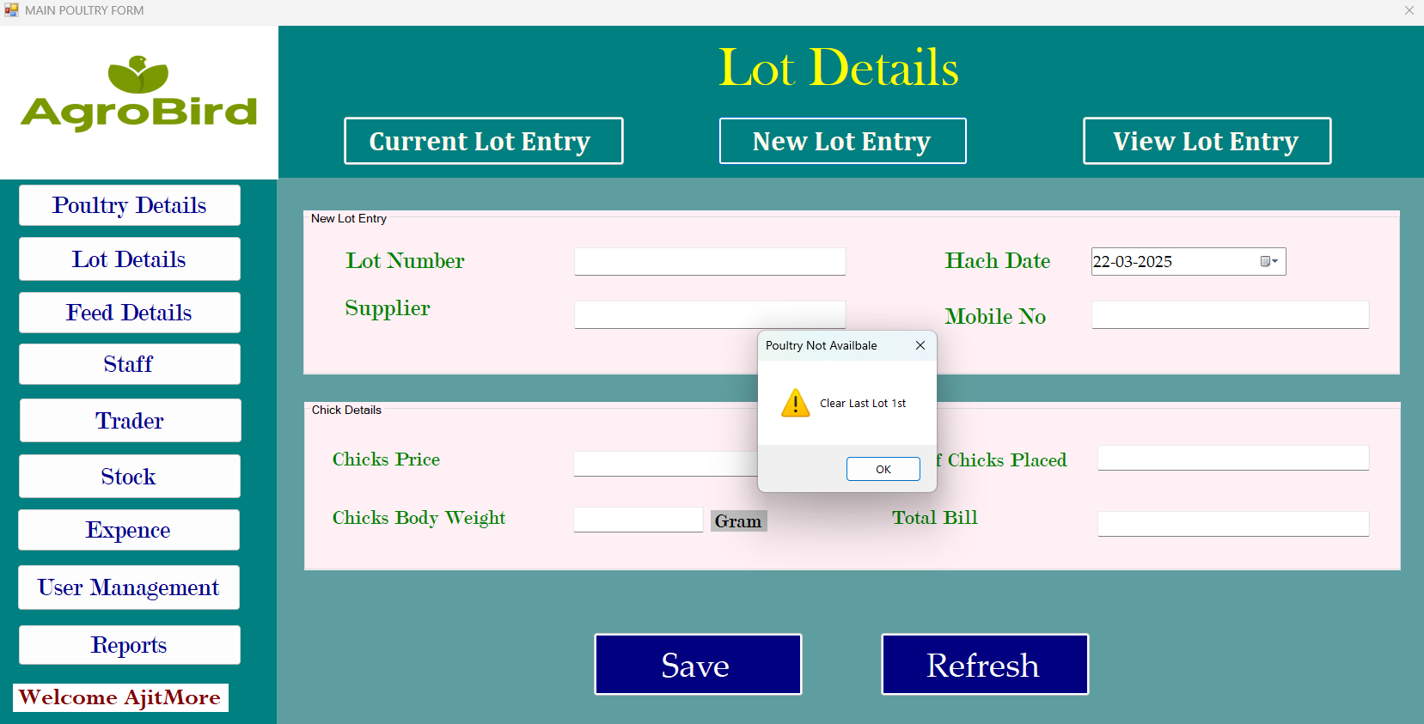

### Feed Purchase Entry:

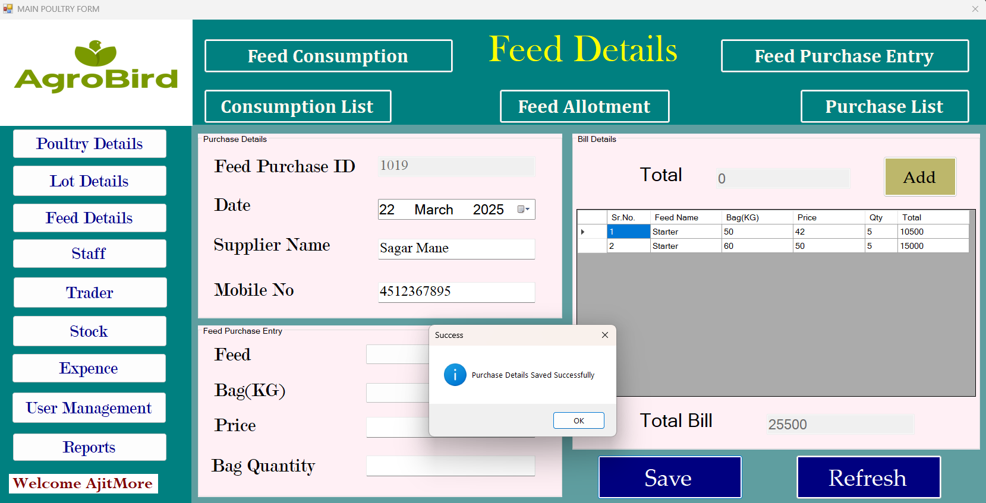

### Feed Consumption:

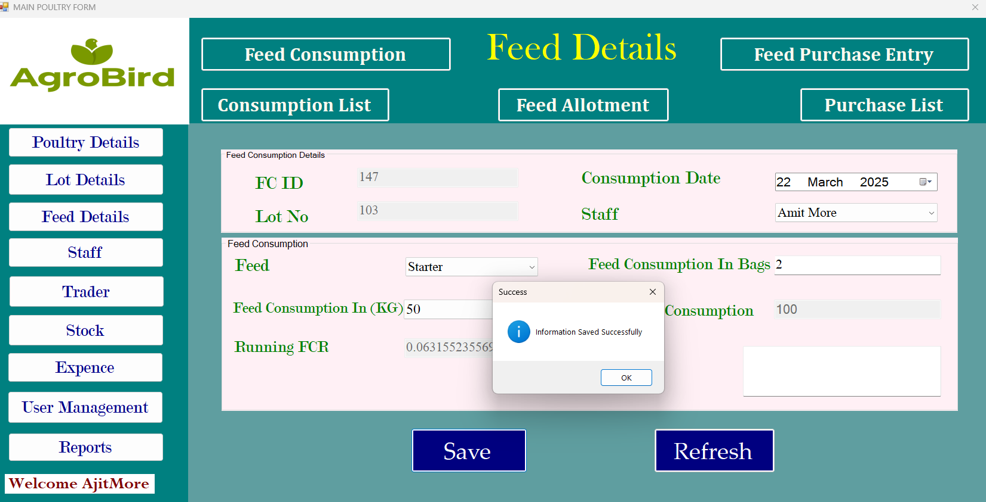

## 

### Add Staff:

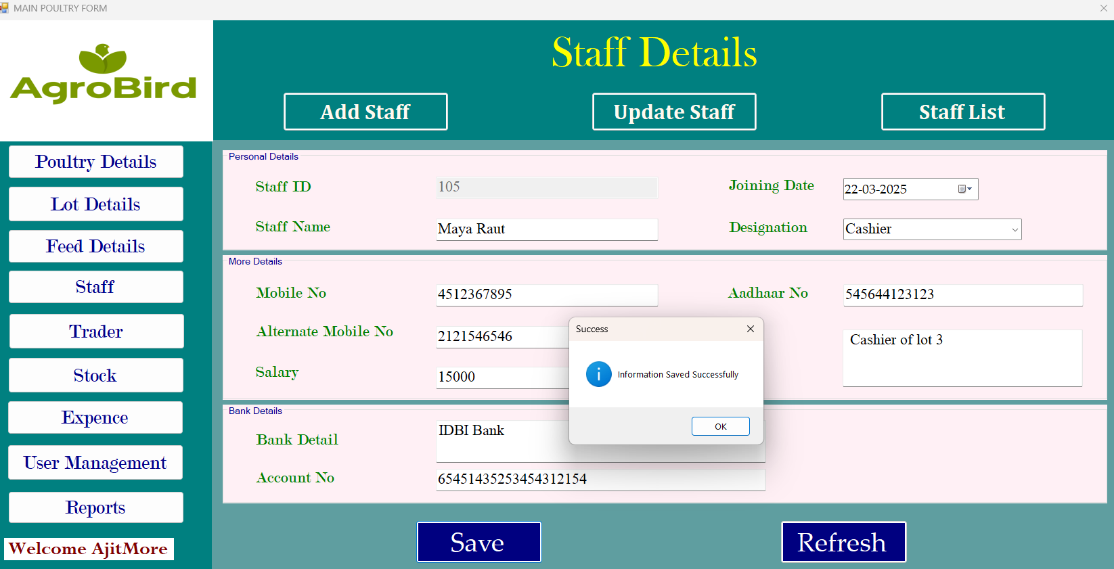

* 1. Staff List:

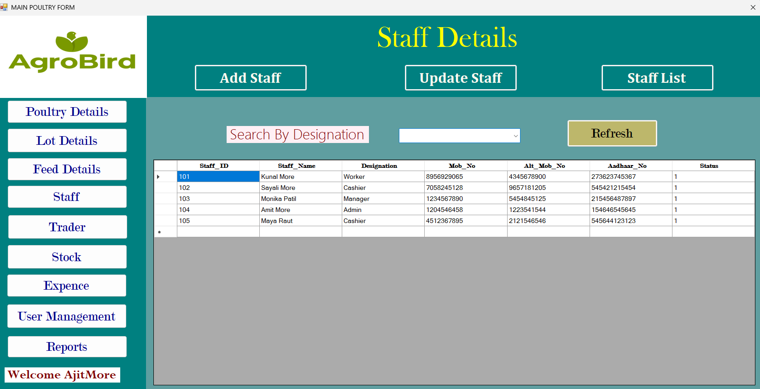



**IMPLEMENTATION**

**CHAPTER 5**



**IMPLEMENTATION**



The implementation of the Poultry Farm Management System involves several key stages to ensure smooth development, deployment, and functionality. The following steps outline the structured implementation process:

**1. Requirement Analysis:** Identify core features such as product management, billing generation, inventory tracking, and reporting.Gather user requirements from Poultry farm manager App owners to understand their business needs.

**2. System Design:** Architecture Design: Implement a 3-tier architecture for modular development (UI Layer, Business Logic Layer , Data Access Layer).Database Design: Design tables for products, customers, invoices, and stock management using SQL Server or MySQL.

User Interface Design: Develop intuitive forms for billing, inventory management, and reporting.

**3. Development Phase:** Use C# with Windows Forms or WPF in the .NET framework for desktop application development.

Implement the following key modules:

Login and User Authentication

Product Management (Add, Update, Delete)

Billing Module (Invoice generation with GST calculation)

Inventory Control

Reporting System (Sales reports, stock details, etc.)

Use ADO.NET or Entity Framework for database connectivity and data manipulation.

**4. Testing:** Conduct Unit Testing to validate individual components.Perform Integration Testing to ensure seamless interaction between different modules.

**5. Deployment:** Prepare the installer using tools like Install Shield or Click Once for easy installation Deploy the application on client systems with proper configuration settings for database connectivity.

**6. Maintenance and Support:** Provide regular updates to enhance functionality.Implement backup solutions to safeguard data.Programming Language: C# (.NET Framework)

Database Management System: SQL Server / MySQL User Interface: Windows Forms.

# 



**SYATEM REQUIREMENTS**



* **Software Requirements**
* Programming Language - C#
* Operating System - Windows 10/11
* Platform - .Net Framework 4.5
* IDE - Visual Studio 2019/2022
* Database - MySQL Server 2019
* Reporting - RDLCorCrystal Report
* **Hardware Requirements**
* Processor - Intel Core i3 (8th Gen or higher)/AMD Ryzen 5
* RAM - Minimum 4 GB (16 GB for smoother multitasking)
* Device - Keyboard and Mouse
* Hard Disk - Minimum 100 GB HDD
* Display - Minimum 1920x1080 resolution for better visibility



**USER GUIDELINE**



**User Guideline for Poultry Farm Management System:**

**1. Login Process:**

Open the application from the desktop shortcut.

Enter your username and password.

Select your role (e.g., Admin, Cashier, Manager) if applicable.

Click Login to access the system.

**2. Dashboard Overview:**

Product Management (Add, Update, Delete)

Billing System (Generate invoices, Print receipts)

Customer Management (Add customer details)

Inventory Management (Stock updates and alerts)

**3. Billing Process:**

Select the Billing module from the dashboard.

Verify product details and quantity.

Click Generate Bill to print the invoice and update inventory records.

**4. Product Management:**

Add Product: Input product details like name, category, price, and stock.

Edit Product: Select an existing product to update information.

Delete Product: Remove outdated or discontinued items.

**5. Report Generation:**

Access detailed sales reports, inventory status, and transaction logs.

Export reports in formats like PDF, Excel, or CSV for analysis.

**6. Logout Process:**

Always log out after completing your tasks.

Click on the Logout button to securely exit the system.

**7. Security Guidelines:**

Use strong passwords and change them periodically.

Restrict admin access to authorized personnel only.



**OUTPUTS**

**CHAPTER 6**

**SCREEN**



**SCREENS AND REPORTS**



* Monthly Feed Purchase Report:

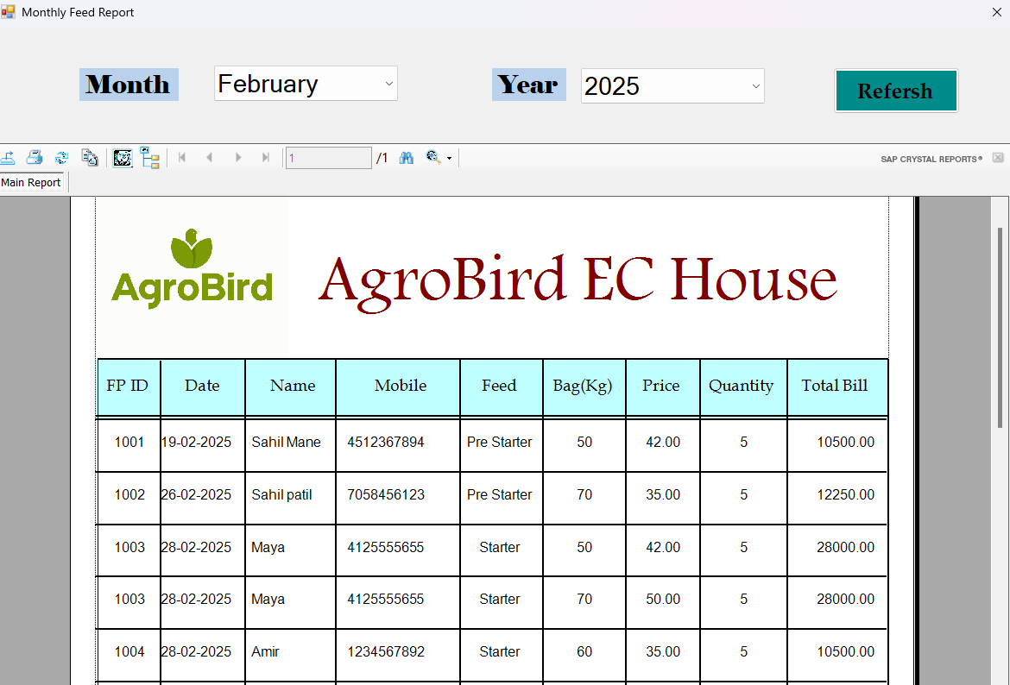

### Feed Purchase Report:

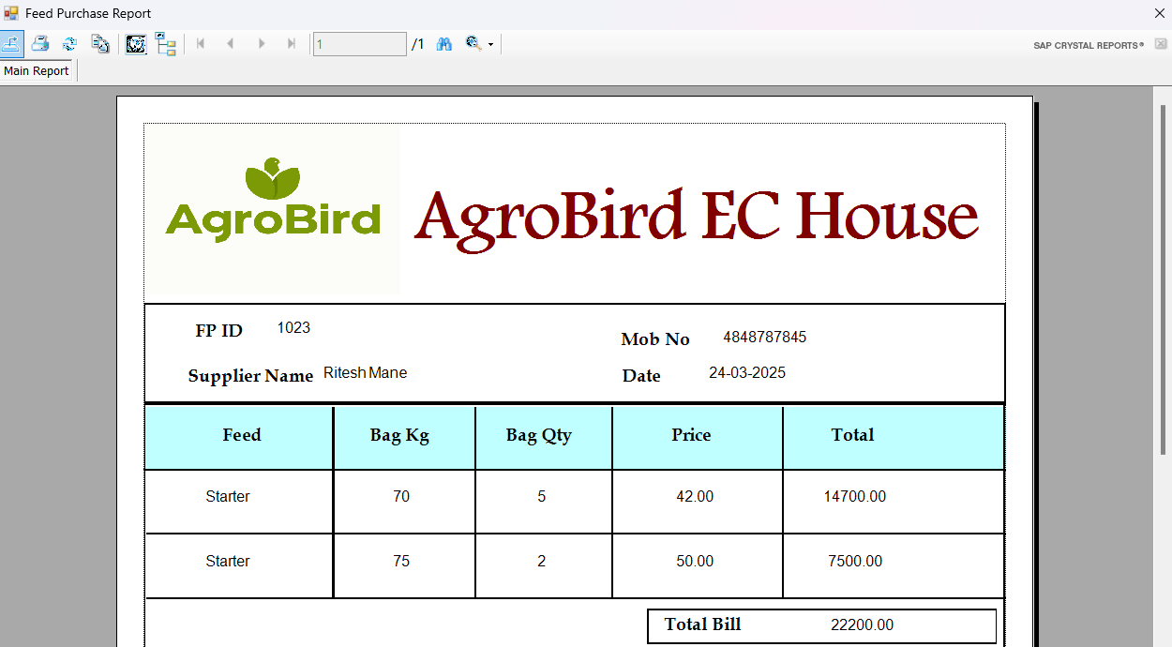

* New Lot Report:

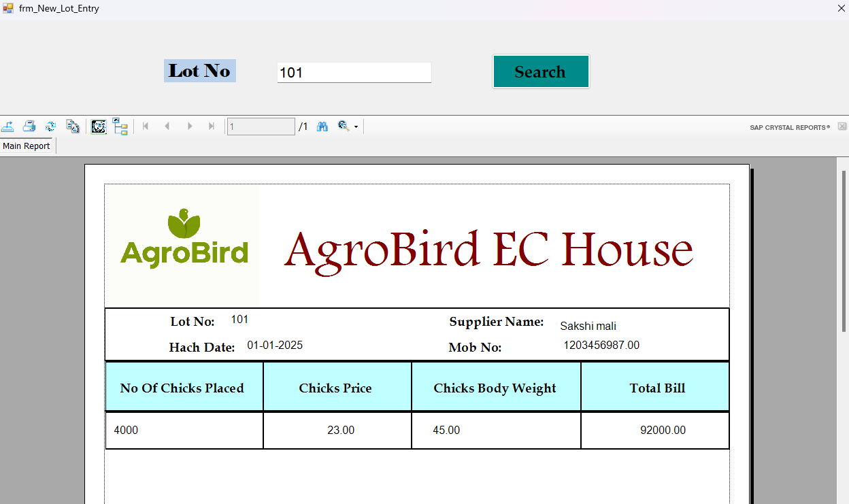

* Lot Current Status DateWise Report:

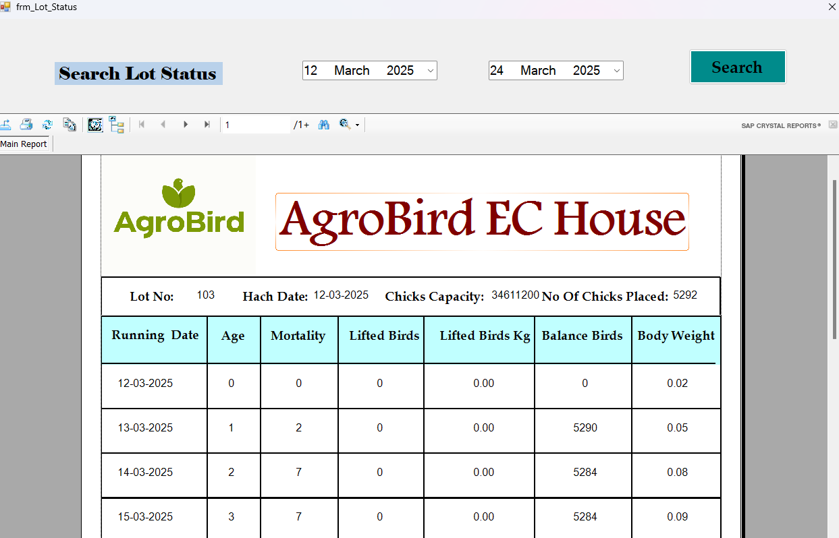

* Lot Dispatch Report:

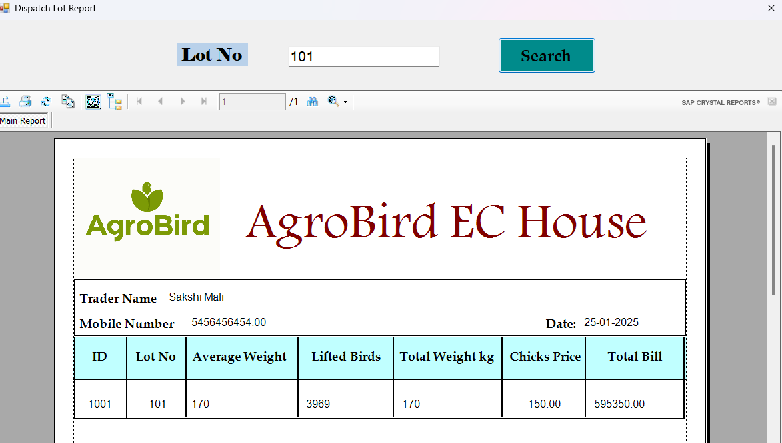

* Expence Report:

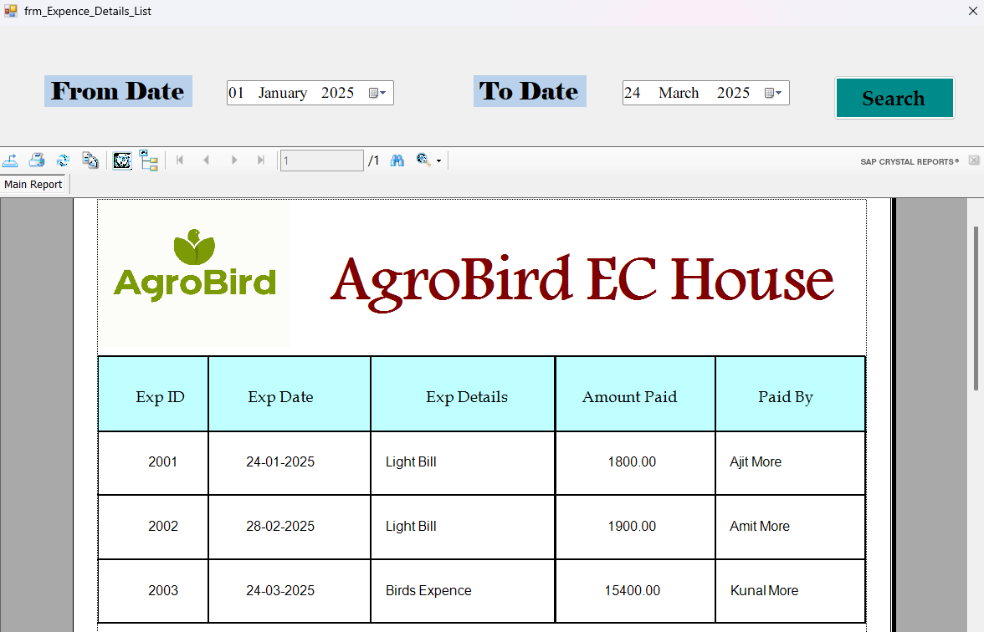



**CHAPTER 7**

**SUGGESTIONS**

**CONCLUSION**

**&**



**CONCLUSION & SUGGESTION**



The integration of a poultry farm manager app in modern poultry farming has revolutionized the industry by providing a comprehensive, data-driven approach to farm management. By leveraging digital technology, poultry farmers can streamline operations, enhance efficiency, and optimize productivity. The app serves as a centralized platform for monitoring crucial farm activities such as feed management, disease control, financial record-keeping, and environmental monitoring.

One of the most significant advantages of a poultry farm manager app is its ability to automate and simplify various farm processes. Traditional poultry farming methods often rely on manual record-keeping and observation, which are prone to human errors and inefficiencies. However, with the introduction of digital solutions, farmers can now track essential farm parameters with precision.

Moreover, a poultry farm manager app enhances financial management by enabling farmers to track expenses, calculate profits, and manage inventory efficiently. Detailed financial records help in budgeting, cost analysis, ensuring that farm resources are utilized effectively.

**Suggestions for Improvement**

To maximize the effectiveness of a poultry farm manager app, several enhancements and features can be incorporated:

1. **AI-Driven Disease Prediction:** Implementing artificial intelligence (AI) and machine learning algorithms can help predict potential disease outbreaks by analyzing historical data, environmental conditions, and bird behavior patterns. This proactive approach can significantly reduce mortality rates and improve overall flock health.
2. **Automated Task Scheduling:** Integrating a task scheduling feature can help farm managers assign and track daily farm activities such as feeding, vaccination, and cleaning schedules. Automated reminders can ensure that all tasks are completed on time, enhancing operational efficiency.
3. **IoT-Based Monitoring:** Connecting the app with IoT (Internet of Things) sensors can enable real-time monitoring of critical farm parameters such as temperature, humidity, and air quality. This data can help in maintaining optimal living conditions for poultry, thereby boosting productivity.



**ENHANCEMENT**

**FUTURE**

**CHAPTER 8**



**FUTURE**



**ENHANCEMENT**



**Future Enhancements**

To further improve the poultry farm management System, the following future enhancements can be considered:

**AI-Powered Analytics**:

* Implement artificial intelligence (AI) to analyze farm data and provide predictive insights on poultry growth, egg production, and feed consumption.

**Automated Feed Management**:

* Integrate automated systems that regulate the feed supply based on real-time consumption data, ensuring the optimal feeding schedule.

**Mobile Access & Notifications**:

* Develop a mobile app version of the application that sends real-time notifications to farm managers about critical events (e.g., low feed levels, temperature fluctuations, health issues).

**Disease Prediction and Monitoring**:

* Implement health monitoring features with real-time data collection and disease prediction algorithms, helping early detection and reducing outbreaks.

**Blockchain for Traceability**:

* Integrate blockchain technology for poultry from farm to market, ensuring transparency and safety in the food supply chain.

**Data-Driven Decision Support**:

* Provide farm managers with reports and insights based on historical and real-time data, aiding them in making informed decisions on operations and management.

**Veterinary and Health Records**:

* Build an integrated system for managing veterinary visits, health checks, vaccination schedules, and medication history for each poultry.

**AI-Driven Feed Formulation**:

* Use AI to develop optimized feed formulations based on the nutritional requirements of different poultry breeds, improving their growth and health.



**BIBLIOGRAPHY**

**CHAPTER 9**

**BIBLOGRAPHY**



**For Visual Studio Installation :**

<https://visualstudio.microsoft.com/>

**Reference Websites :**

<https://visualstudio.microsoft.com/msdn-platforms/>

<https://learn.microsoft.com/en-us/dotnet/csharp/>

**Books :**

**1.** Software Engineering

By Rower Pressman

**2.** System Analysis & Design

By E.D. Wad

**3.** Database System Concept

By Korth Siebrecht